**Functional Document**

|  |  |
| --- | --- |
| **Application** | NGERP - Centra |
| **Service Bundle** | Integrations |
| **Service Request** | Import Budget (Manual) |

**Description :**

User can manually import Budget using File Loader or P2P integration. The total budget to conduct the marketing campaign is mentioned in the budget screen.

**Workflow Process :**

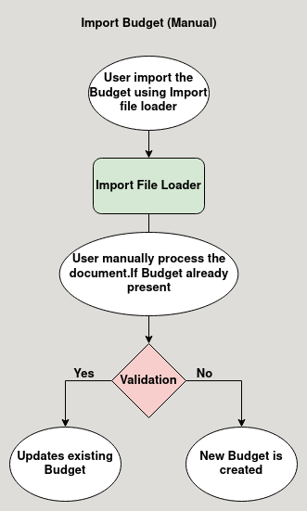

**Business Rules :**

* User can import Budget in file loader in HQ only.
* While importing a already present Budget it be updated.
* After importing the budget in the file loader user process it manually in the import budget temporary screen.
* After processing it will be loaded in the budget screen.